**adidas Group – Setting up Active X for Remote Control through Software Central**

This document explains setting up prerequisites for remote control through Software Central.

Author: **Karthickumar K**

Intended Audience: **SCCM 2012 Project / Regional Admins/ SCCM Support Personals**

Classification: **Internal Use Only**

Table of Contents

Introduction 3

Installing Software Central Active X 3

# 

# Introduction

For the Software Central remote control to work, we are required to install Active X on the local system from where we are trying to connect a remote workstation. This document will explain the step by step procedure for setting up the Service desk system for remote connection.

# Installing Software Central Active X

1. Download the SoftwareCentral Active X from this SharePoint link.
2. Save the zip file and extract it to your machine.
3. Close your Internet explorer.
4. Open the SWCSignedActiveX V 2.0.1.msi file and double click to begin your installation.

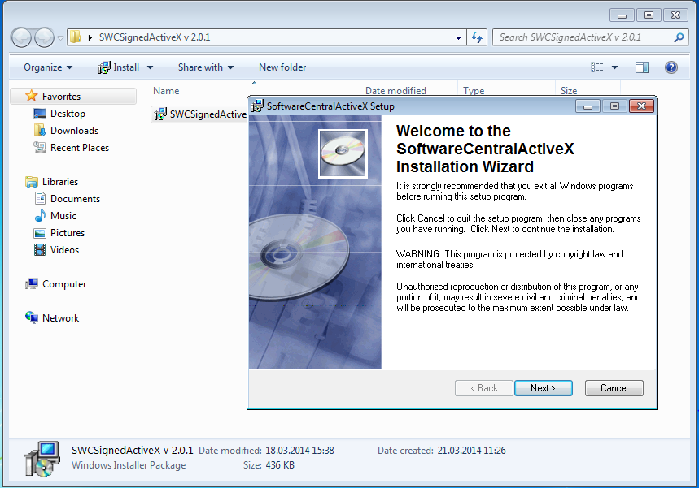

1. 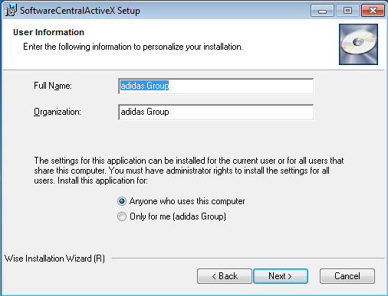Install it for all the users on your computer or use only for me as required and click Next.
2. Set the installation path (Destination Folder) and click Next twice.

# 

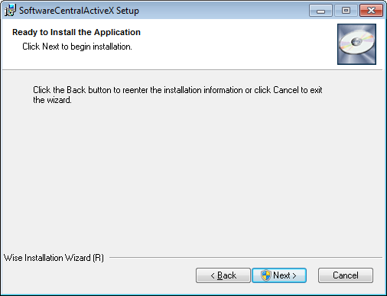

1. Setup will begin and will ask you to Click Finish to complete the installation. Click Finish.

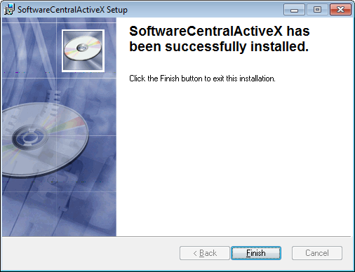

1. Verify that you’re able to connect to a remote system from Software Central by choosing the Remote Control from Tools menu, choosing a test client and Clicking Connect.

